**Neural Networks & Deep Learning - Assignment 4**

**GitHub Link:**

[**https://github.com/YaminiSai786/CS5720-Neural-Networks-Deep-Learning---ICP**](https://github.com/YaminiSai786/CS5720-Neural-Networks-Deep-Learning---ICP)

**Videos Link:**

[**https://github.com/YaminiSai786/CS5720-Neural-Networks-Deep-Learning---ICP**](https://github.com/YaminiSai786/CS5720-Neural-Networks-Deep-Learning---ICP)

**Program 1**

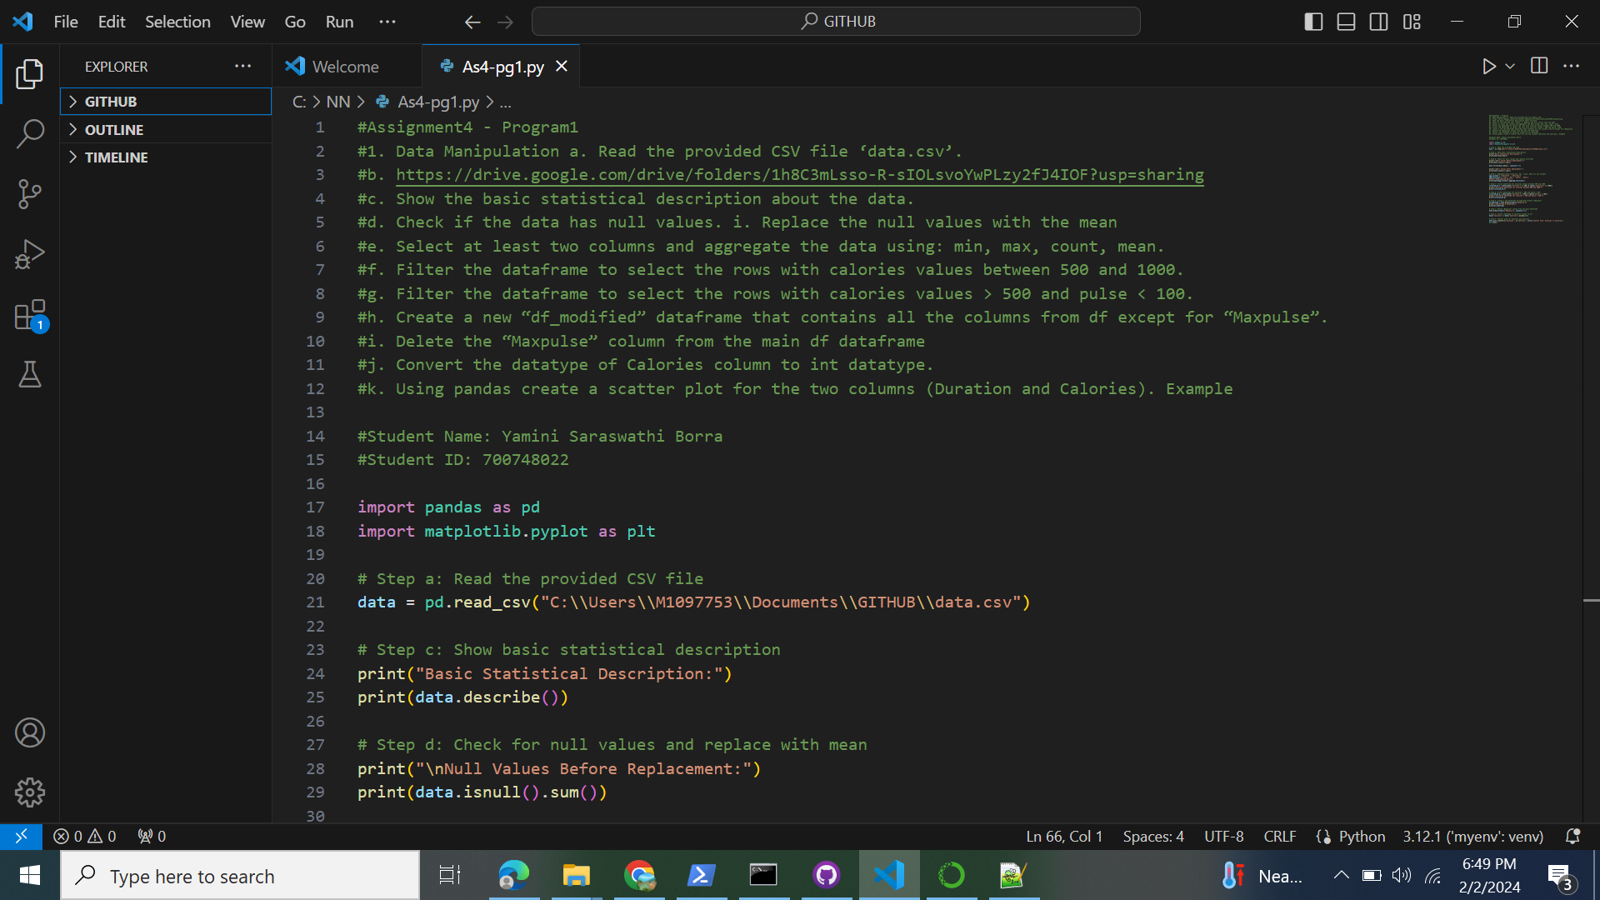**[1]**

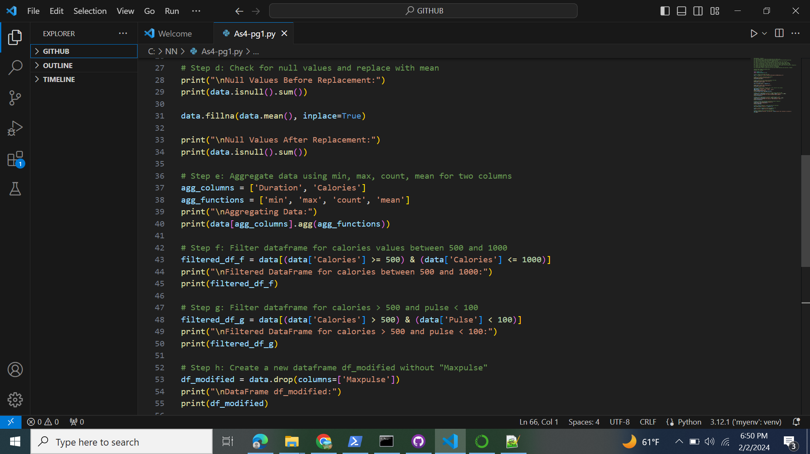

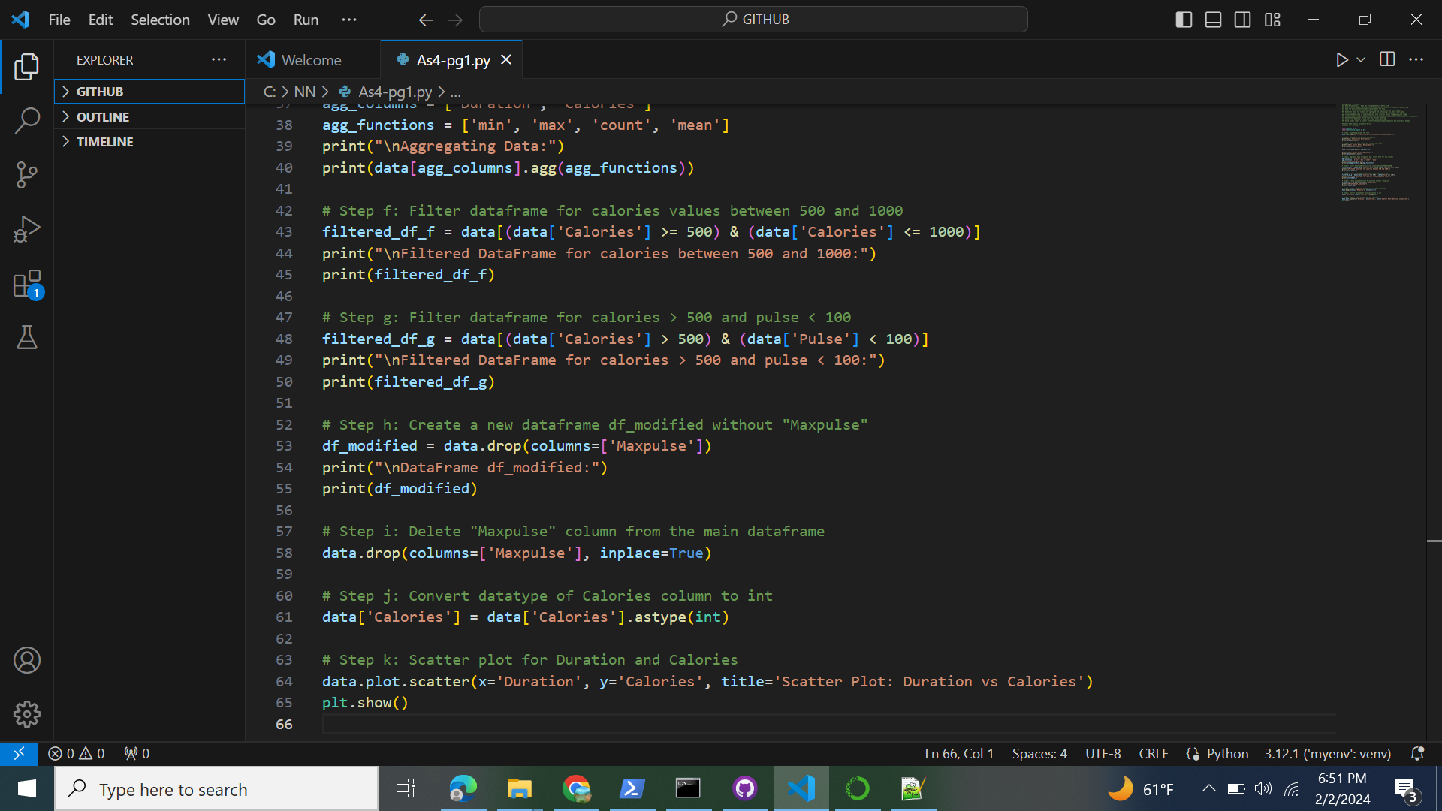

**P[2]rogram1 - Result**

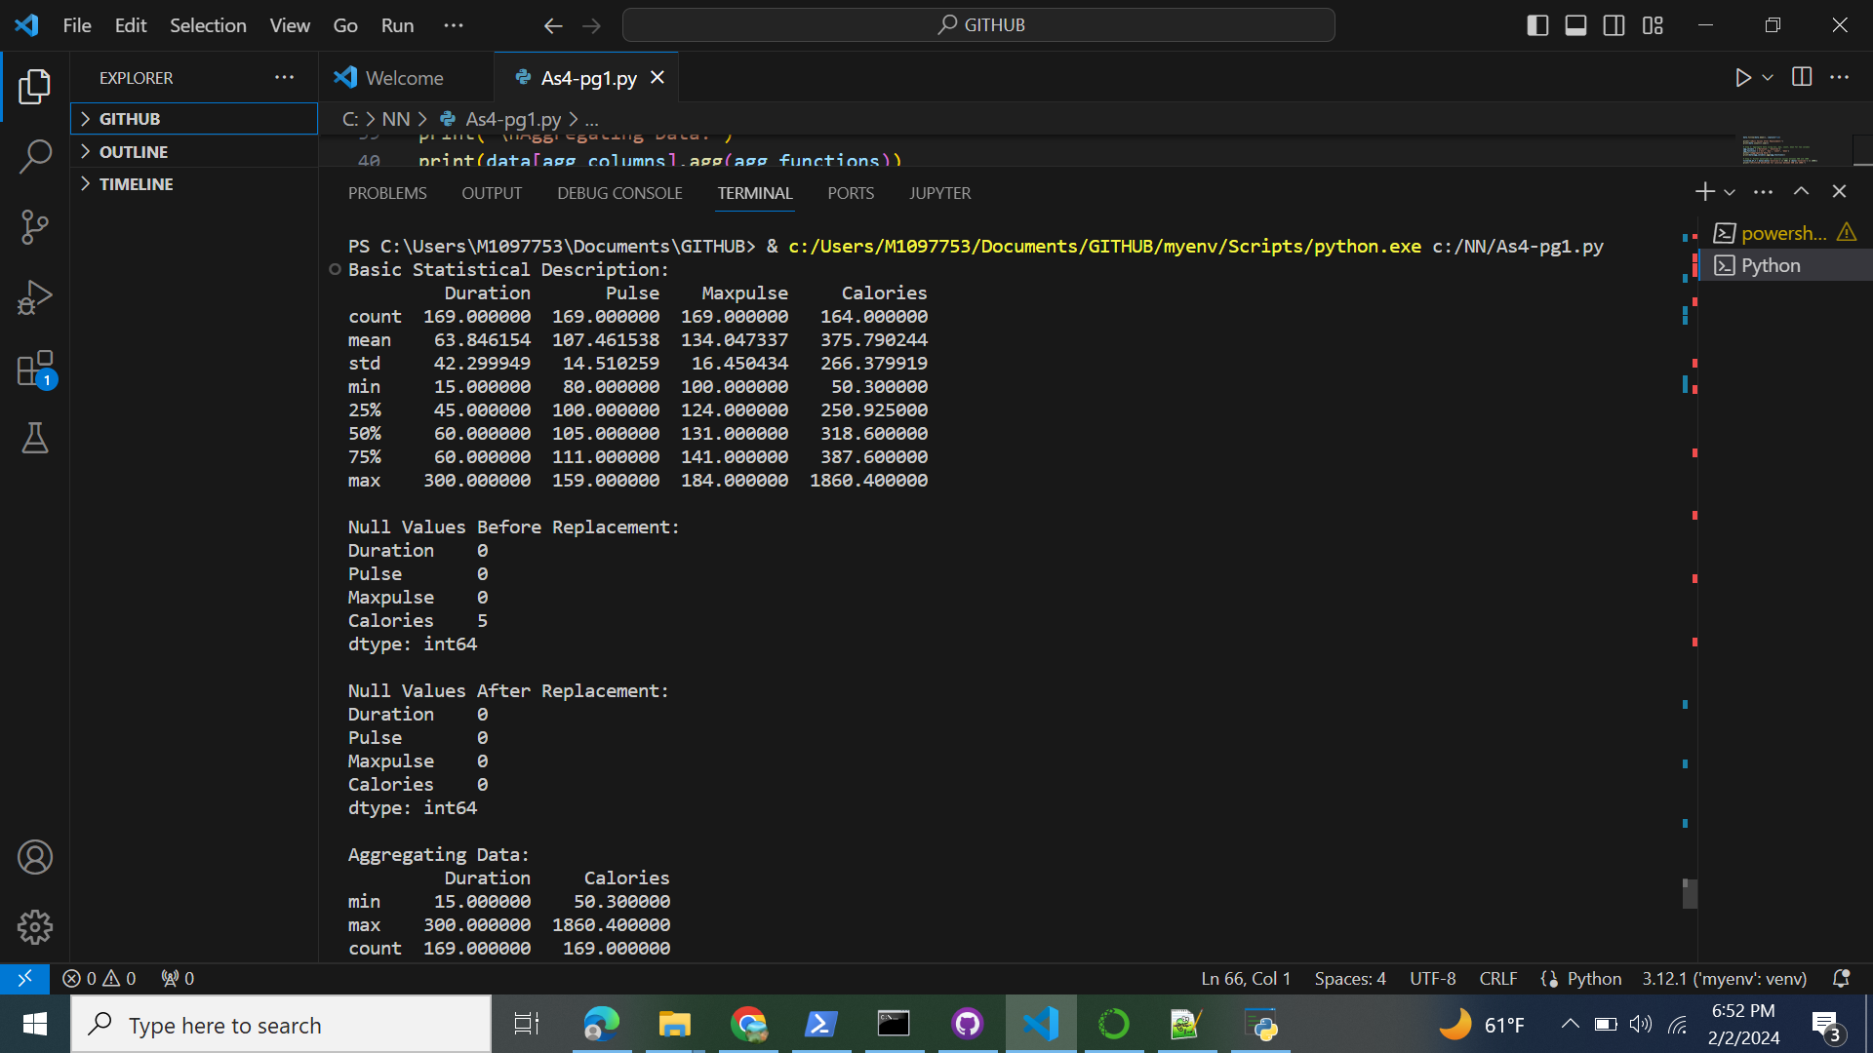

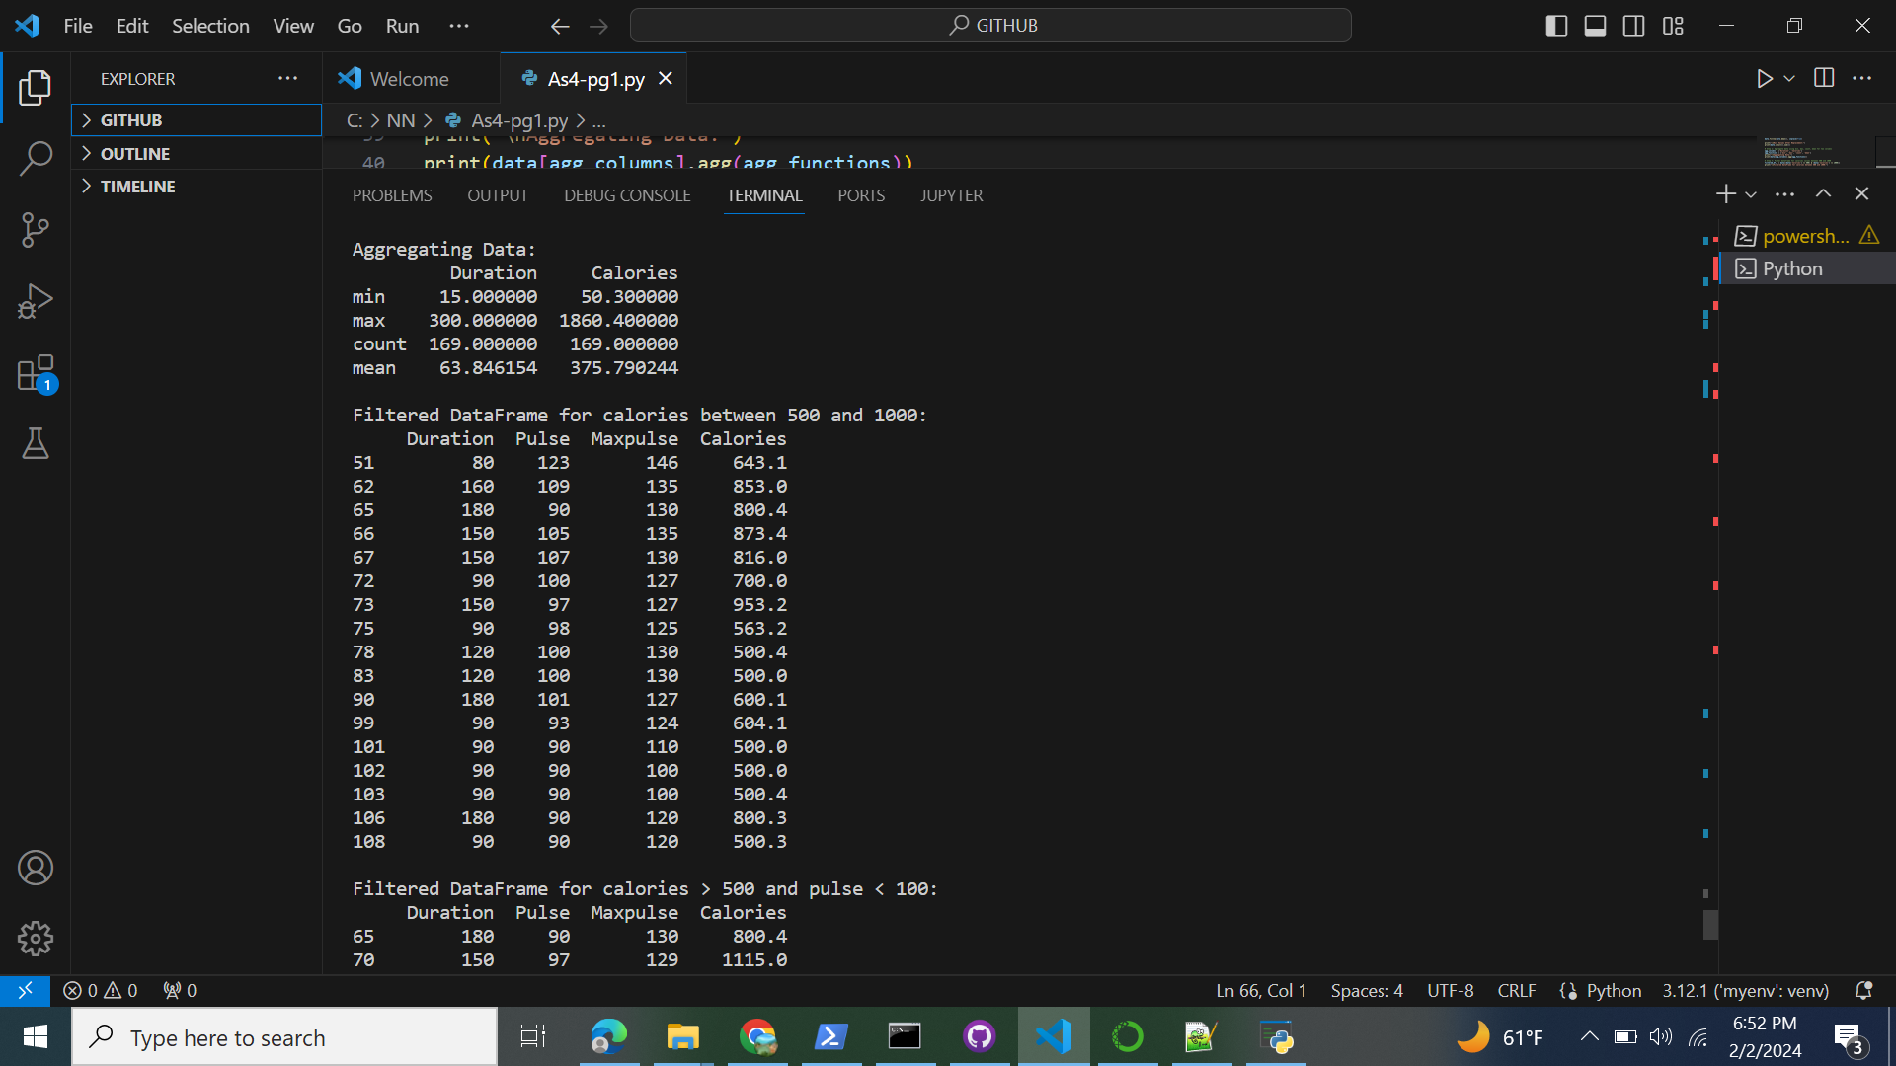**[3]**

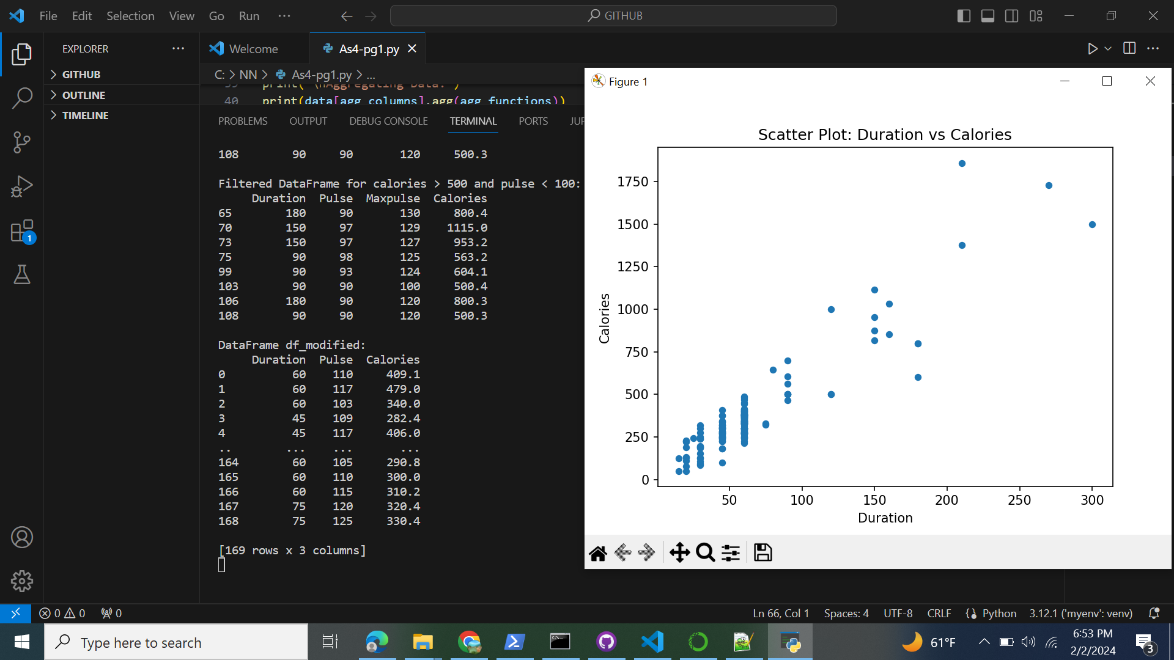

**Program 2:**

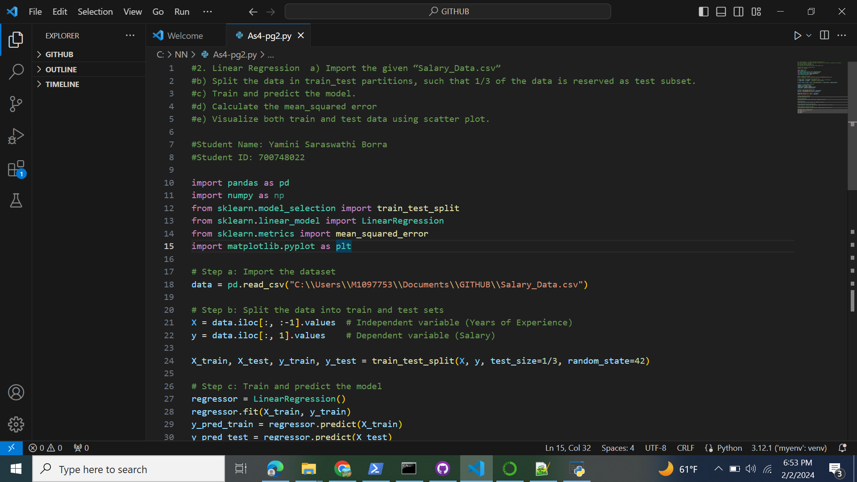**[4]**

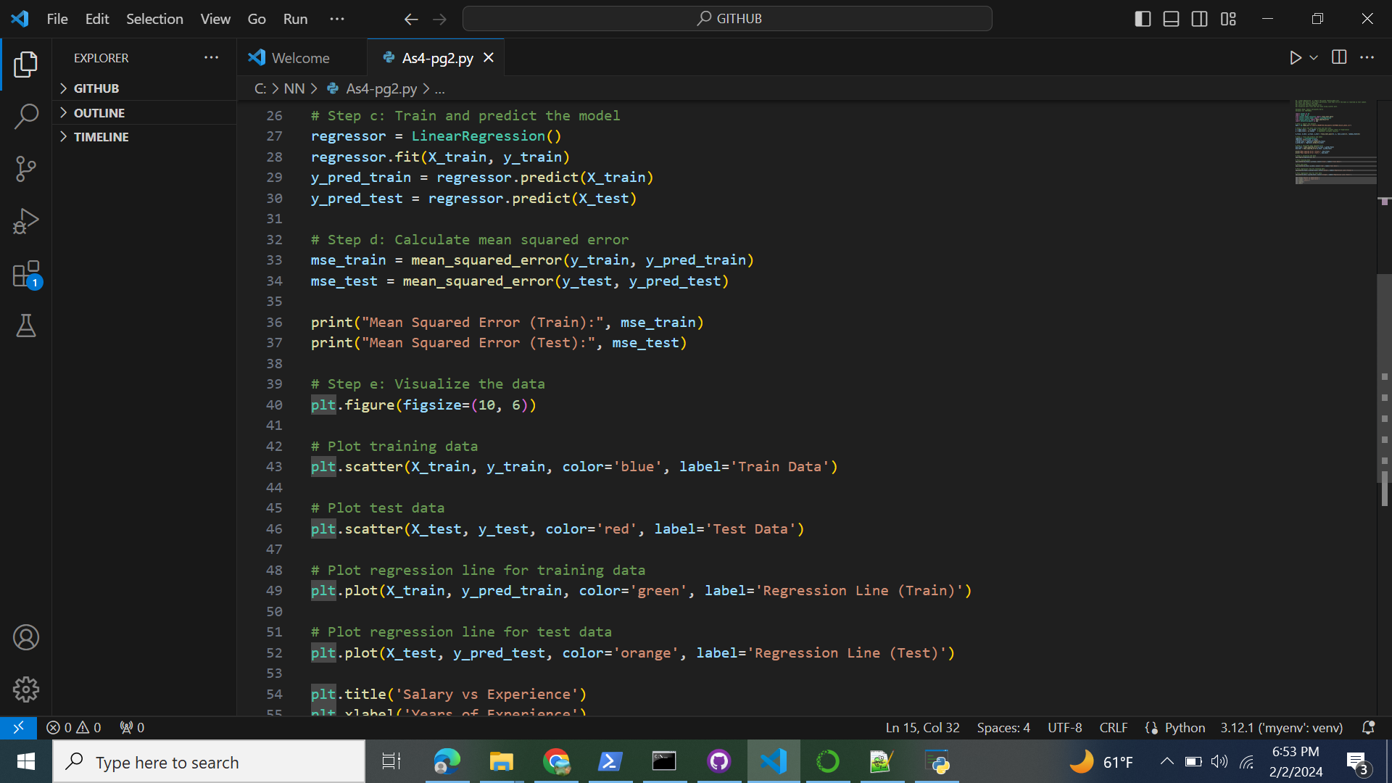

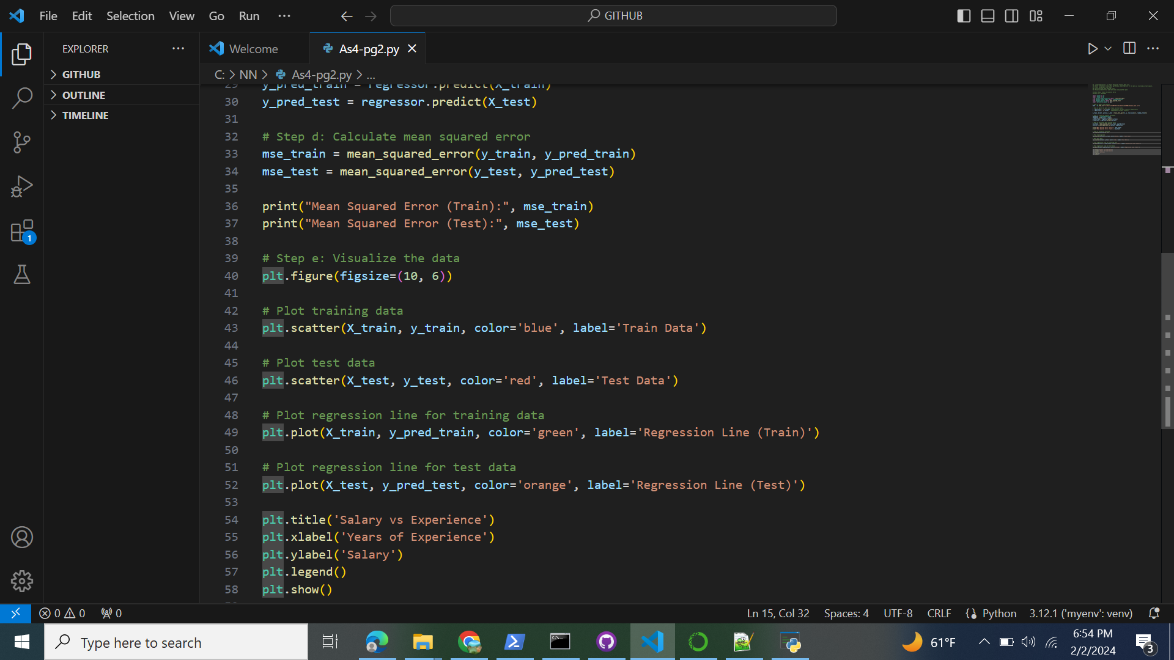

**Program2 - Result[5]**

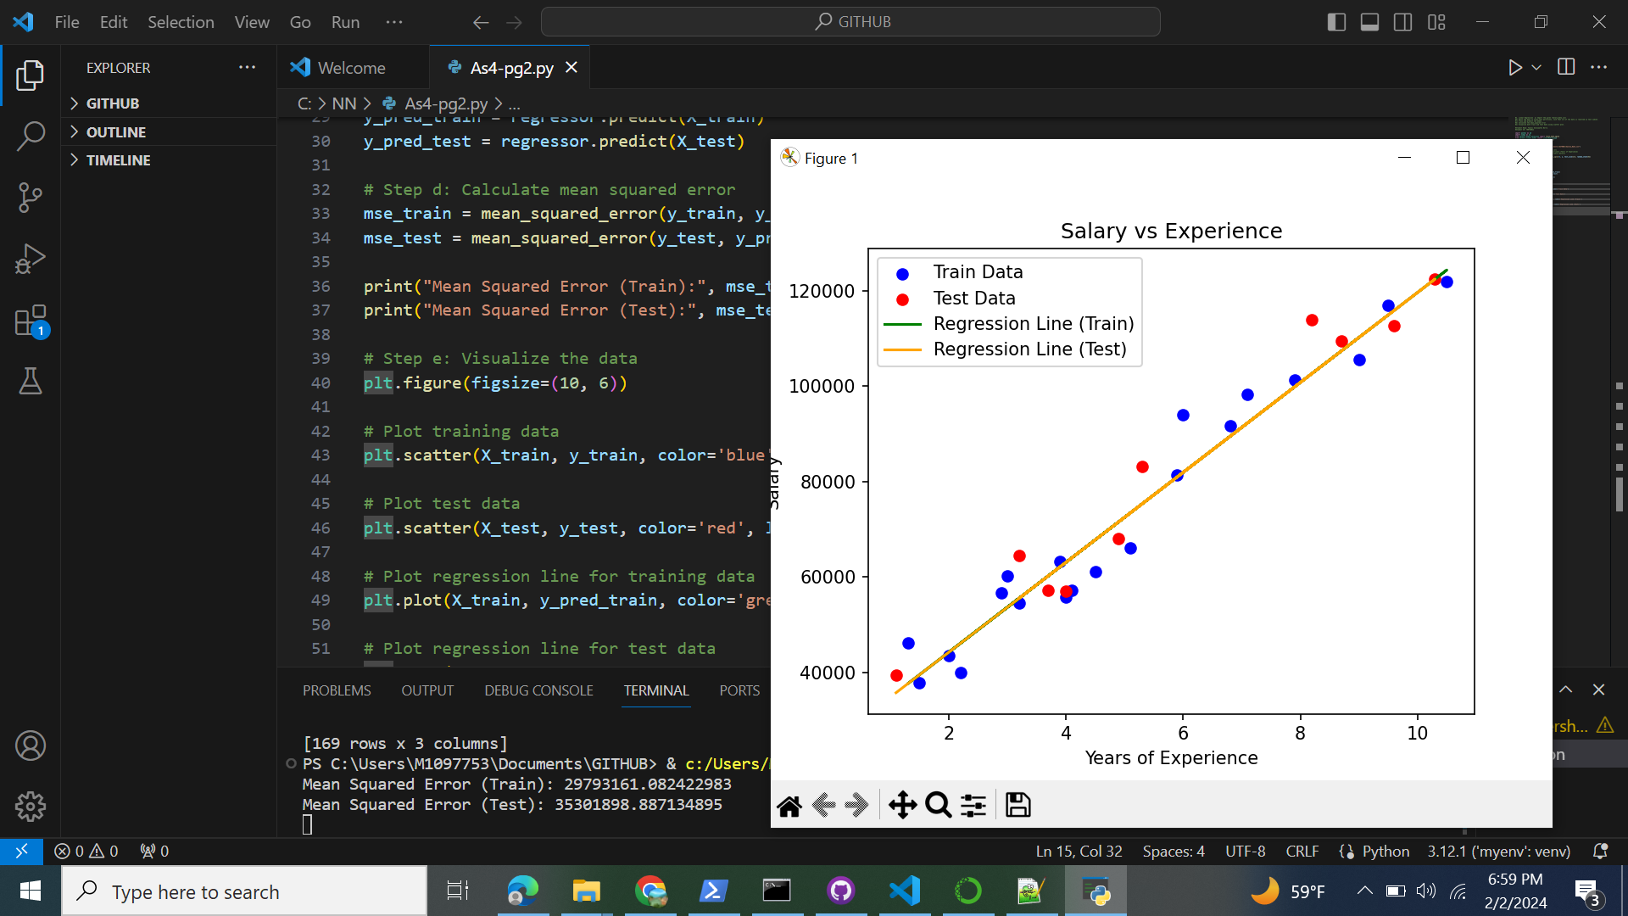**[6]**

1. Yamini Saraswathi Borra - 700748022 NNDL - Assignment 4
2. Yamini Saraswathi Borra - 700748022 NNDL - Assignment 4
3. Yamini Saraswathi Borra - 700748022 NNDL - Assignment 4
4. Yamini Saraswathi Borra - 700748022 NNDL - Assignment 4
5. Yamini Saraswathi Borra - 700748022 NNDL - Assignment 4
6. Yamini Saraswathi Borra - 700748022 NNDL - Assignment 4